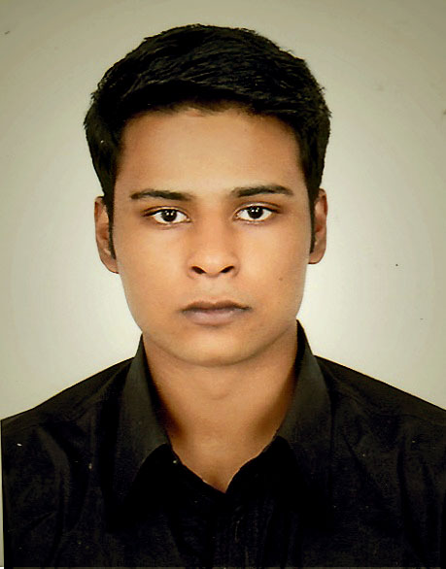

CV of Imtiazul Alam

# CAREER OBJECTIVE

Worked for a reputed American organization for the last 5 years and want to carry on working for more reputed and versatile organizations with the highest level of professionalism, integrity, creativity and contribute to its continued growth and success.

# PERSONAL INFORMATION

|  |  |
| --- | --- |
| Nationality: | Bangladeshi |
| Resident of: | Bangladesh |
| Birth date: | 25th October 1991 |
| Gender: | Male |
| Marital Status:  Mobile no :  e-mail id : | Single  +8801724289855, +8801676265939 [borshan11@hotmail.com](mailto:borshan11@hotmail.com), [borshan10@gmail.com](mailto:borshan10@gmail.com) |

# EDUCATION

# Diploma in Hospitality and Tourism 2014

Legend International College of Hospitality and Tourism

(Kuala Lumpur, Malaysia)

# G.E.D 2010

G.E.D Center (Dhaka, Bangladesh)

# Secondary School Certificate (S.S.C) 2008

Scholars School and College (Dhaka, Bangladesh)

# Schools

Saint Paul’s School (Darjeeling, India)

Dhanmondi Tutorial (Dhaka, Bangladesh)

# PROFFESIONAL EXPERIENCES

Refunds Manager for Imprint.com  
Dhaka, Bangladesh  
  
Claims Analyst for Imprint.com  
Dhaka, Bangladesh  
  
Customer Service Team Leader for Imprint.com  
Dhaka, Bangladesh  
  
  
Management Trainee for Imprint.com  
Dhaka, Bangladesh  
  
Marketing Intern for The Westin  
Dhaka, Bangladesh

Floor Manager for Tony Roma’s Restaurant

Kuala Lumpur, Malaysia

Restaurant Manager at Legenda Cafe

Kuala Lumpur, Malaysia

Restaurant Supervisor at Legenda Cafe

Kuala Lumpur, Malaysia

# PROFFESIONAL PART TIME EXPERIENCES

Data Entry Admin at Annual Architects Convention 2011-2013

Kuala Lumpur, Malaysia

Banquet floor manager for Sunway Putra Hotel

Kuala Lumpur, Malaysia

Waiter at Tony Romas

Kuala Lumpur, Malaysia

Waiter at TGI Fridays

Kuala Lumpur, Malaysia

Bartender at Beer Factory

Kuala Lumpur, Malaysia

Barback at The Ministry of sound

Kuala Lumpur, Malaysia

# COMPUTER SKILLS

Sufficient knowledge on general software’s and hardware’s including most Microsoft Office tools like MS Word, MS Excel, Power point etc

# LANGUAGES

English, Bengali, Hindi and French.

# References: Aziz Al Mansoor Managing Director Imprint.Com 14550 Beechnut St, Houston, TX 77083-5741 Email: [aziz@imprint.com](mailto:aziz@imprint.com),

**Rownak Alam**  
  
National Senior Communication Expert  
Promote Access to Land in Bangladesh  
DLRS, 28, ShahidTajuddinSarani

Tejgaon, Dhaka-1208, Bangladesh.

Cell: +88-01711 641176

Email: [rownakin@gmail.com](mailto:rownakin@gmail.com)

[rownakin@yahoo.com](mailto:rownakin@yahoo.com)

**Linda Bartholome**

Ketua Exsekutif

Head of Collage

Legend International Collage of Hospitality & Tourism

Lot 10.3.2, Greand Seasons Avenue

No. 72 , Jalan Pahang, 53000 Kuala Lampur

Tel: 603-27717772/7771, Fax : 603- 27717770

Email : [lindabartholome@gmail.com](mailto:lindabartholome@gmail.com)